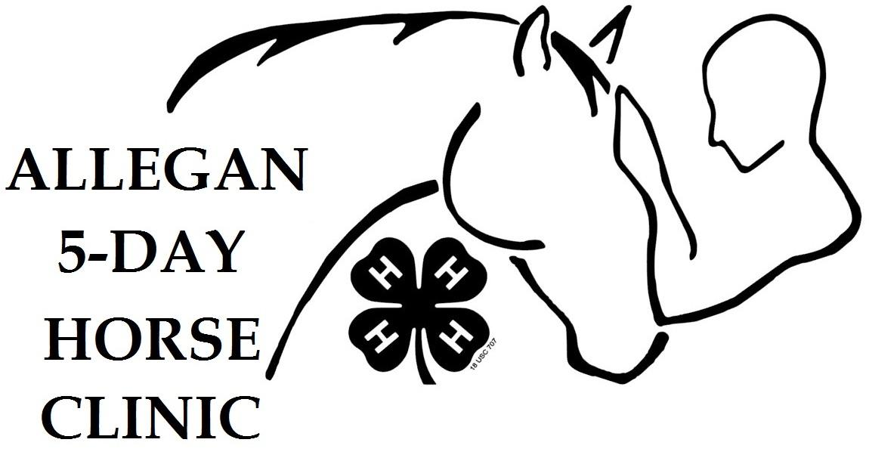
Friday June 19th
thru
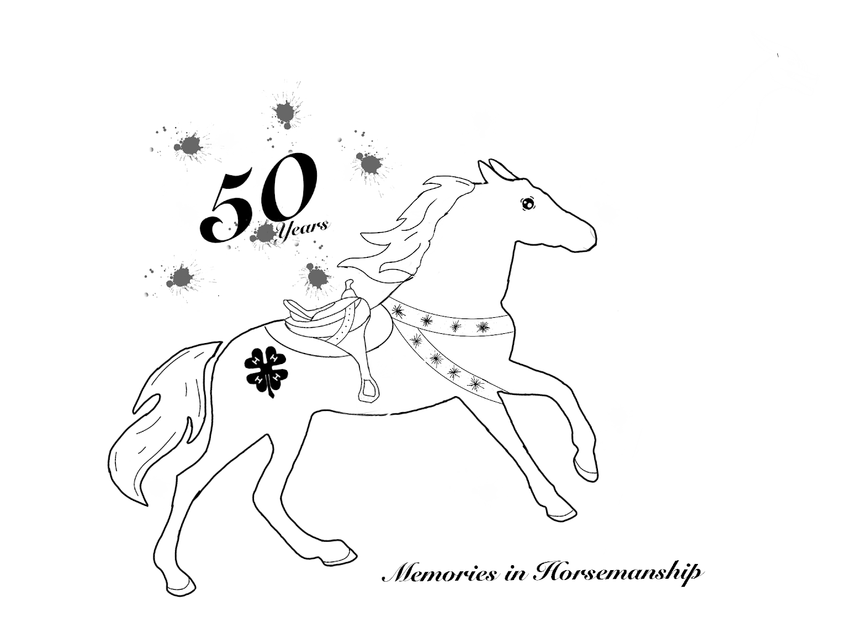
Wednesday June 24th 2026

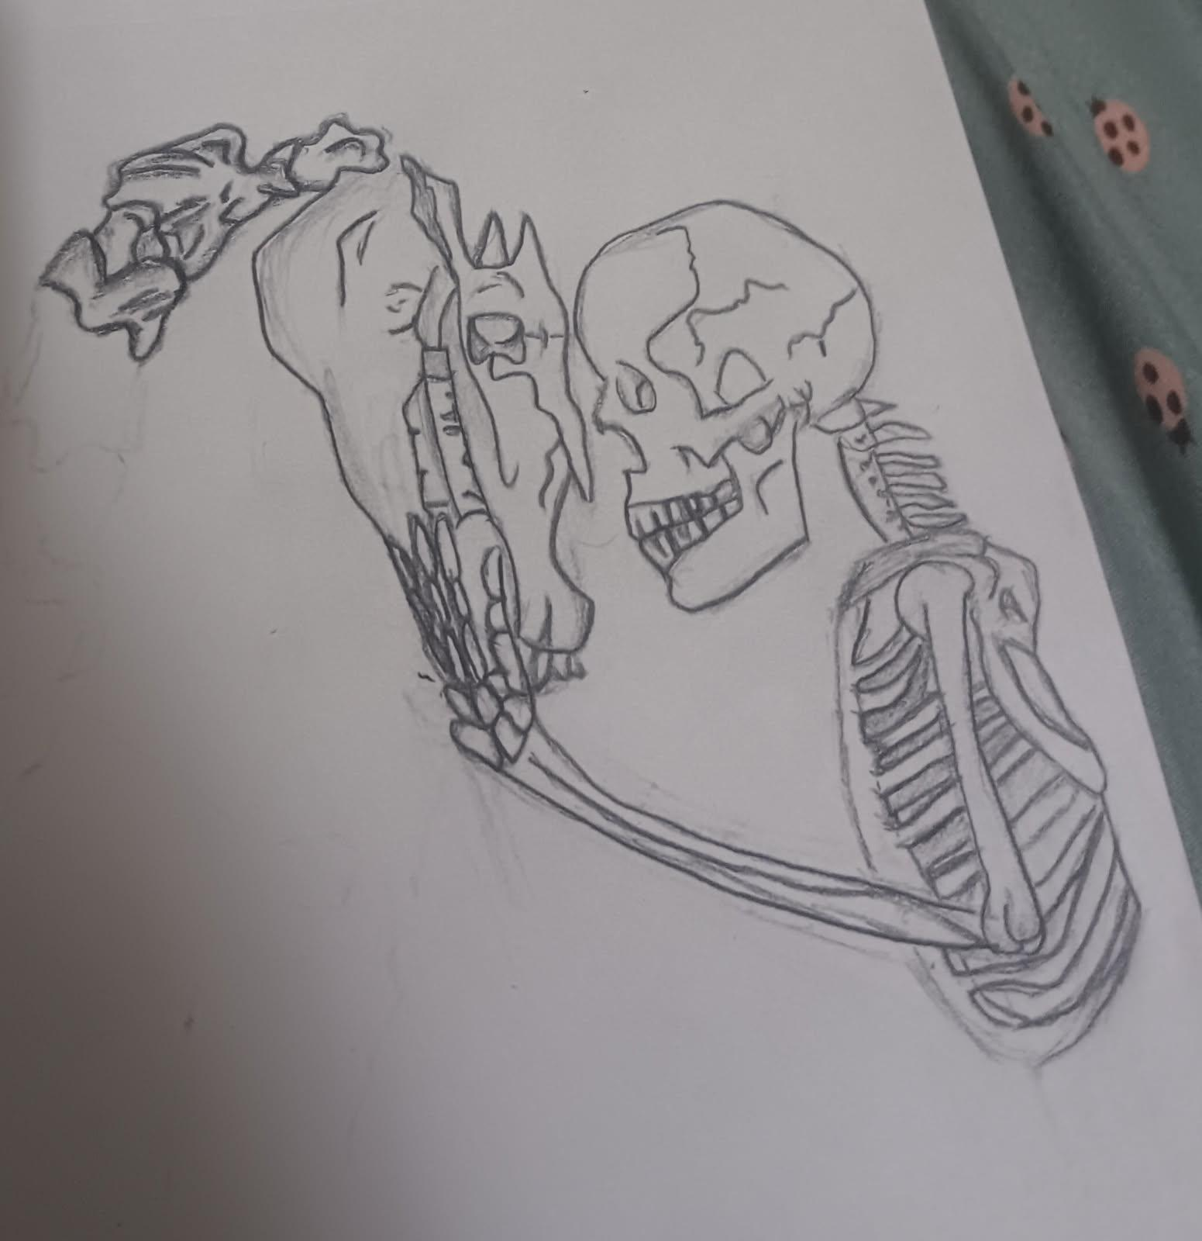

Photo credit: Selah Mikel

MSU is an affirmative-action, equal-opportunity employer. Michigan State University Extension programs and materials are open to all without regard to race, color, national origin, sex, gender, gender identity, religion, age, height, weight, disability, political beliefs, sexual orientation, marital status, family status or veteran status.
Registration Information
- Registration is May 5th, 2026 thru May 25th, 2026.
- Late registration is May 26th to June 9th and WILL BE CHARGED A $15 LATE FEE per person.
- Online registration CLOSES on June 9th at 11:59pm 2026.
- Please register online-at https://5dayclinic.org.
- Read the registration information and then sign up to register for classes.
- SEI/ASTM approved helmets are required for all classes in the arena and in the round pen.
- The following youth participants will need to be evaluated PRIOR to clinic: Evaluation information is available on the website.
  - First-time clinic participants.
  - Those wanting to move up a level.
  - Those that have had a change of horse.
  - First-time driving or jumping participants.
- Youth may register for up to THREE 90 minute riding classes Youth may additionally register for non riding classes.
- Class fees are $65.00 per class (Discount: 3 classes for $180).
- Clinic updates will be posted at https://5dayclinic.org and the Facebook page

How to Register
- Register online at https://5dayclinic.org You will need photos of:
  - Proof of immunizations
  - Negative coggins results
  - Copy of your Horsemaster riding evaluation
- Click the “Register Here” link and follow the directions.
- Send checks to Kerisa Desimone 2797 10th St Shelbyville MI 49344, Make check payable to Allegan County Five Day Clinic. PAYMENT MUST BE RECEIVED WITHIN 7 BUSINESS DAYS OR YOUR REGISTRATION WILL BE DELETED AND YOUR CLASS SPACE WILL NOT BE RESERVED
- Please email 4H Incentives to allegan5day@gmail.com
- When payment is received you will be emailed a confirmation notice

Special Notes
- Class sizes are limited and will fill on a first come first serve basis. Classes will close when they are filled. Waitlists will be available.
- Cash payments may be made by apt. only. No credit/debit cards accepted. No PayPal.
- Paper Registrations may also be mailed to Kerisa Desimone. Please note: Paper registrations take longer and class choices may not be available by the time registrations are received.
- Reimbursements will be considered by the 5 Day Committee on a case by case basis for extreme extenuating circumstances only. A Doctor’s or veterinarian’s note may be required.
- Please email 4H Incentives to allegan5day@gmail.com.
- Non-Cloverbud participants must be 8 years old by January 1, 2026; or older and should be able to, at a minimum, control their horse/pony at a walk and trot.
- If you have any registration questions or concerns please email allegan5day@gmail.com.

Horse Health Requirements
- It is highly recommended that horses and ponies be properly conditioned before clinic and ready for strenuous exercise.
- Horses should be up to date on all routine care including farrier work.
- For the protection of your horse/pony, all animals must receive Flu, Tetanus, WEE and EEE shots. Also a current negative Coggins test is REQUIRED. West Nile Virus, VEE, Strangles, Rhino and PHF vaccines are strongly recommended, but not required. All immunizations should be given 3-4 weeks before the clinic in order to be effective.
- Proof of Immunizations & Coggins must be uploaded during registration or emailed to Allegan5day@gmail.com.
- Vet checks will be done before classes begin to ensure the safety of horse and rider.

Stall Information
- Horse and Tack stalls will be assigned by the barn managers and grouped according to 4H clubs. Tack stalls will be shared.
- Horses cannot be tied to trailers during the day or left in trailers at night.
- Emergency Contact Stall Card must be attached to the stall as soon as the horse is inside. Stall cards will be available at the clinic office.
- Stalls are expected to be scraped clean with no shavings. All staples must be removed from front of stalls.
2026 5 Day Clinic Rules
- Clinic hours are from 8am to 9:30pm.
- All youth will participate in their scheduled activities. Please be on time.
- Be prepared for sun, heat, rain or inclement weather.
- All participants must obey safety procedures and rules given by the instructors.
- Do not enter assigned areas until told to do so by the instructor.
- Our clinic is limited to a given area on the fairgrounds. Do not wander into other areas.
- Those youth participants staying with a leader should have a signed parent emergency release form.
- Horse and ponies are to be under control at all times.
- Horses and ponies will not be ridden outside of class.
- Horses and ponies will be ridden in full tack at all times unless directed by an instructor.
- All equipment used must be well-fitting and of safe quality.
- NO electronic devices or ear buds while in class.
- For safety reasons instant obedience is a must. “Freeze” is a command to be given when a hazardous or potentially hazardous situation develops. It means stop all activity immediately and look around to see what’s wrong.
- Safety and courtesy are to be practiced at all times.
- SEI/ASIEM approved Helmets will be worn by all students while in the arena and round pens.
- All clinic staff and committee members must be obeyed at all times.
- Health & Release forms need to be completed and the release policy followed.
- No dogs or bikes.
- NO switching horses throughout clinic without prior instructor approval.

Barn Rules
- Emergency Contact Stall Card must be attached to the stall door as soon as the horse is in it.
- Stall doors are to be kept closed when not in use.
- Wheelbarrows and all tools are to be kept in trailers or tack stalls if available.
- Horses are expected to have 2 buckets of water during hot weather.
- Horses may not be tied to the outside of the stalls.
- Closed shoes or boots worn at all times around horses.
- No loud noises and “horse play” or water fights around horses.
- Manure is to be placed in designated areas only.
- Youth are to stay away from barns from 10:30pm until 6:30am unless authorized by a Barn Manager or there is an emergency. Quiet time begins at 11:00pm. Please be considerate of sleeping horses.

Behavioral Expectation of 4-H Leaders/Members/Parents
4-H Horse leaders and members when participating or acting on behalf of the Allegan County 4-H Youth Program are expected to conduct themselves in accordance with accepted standards of social behavior, to respect the rights of others, and to refrain from any conduct which may be injurious to the program. It is expected that 4-H Leaders and members will conduct themselves according to the code of conduct they signed as part of their 4-H enrollment in 4HOnline.

Contests and Awards
Stall Decorating Contest: Our 5 day theme is “Beach Party.” Everyone is encouraged to decorate their stalls incorporating this year’s theme. The 5 Day committee and instructors will vote and the top 1 group will get a $50 Pizza Hut Gift Card. Participants that are coming without a 4-H group can join another group or do their own decorations as open participants. Staple guns are available in the office. Please note: all the staples have to be removed by the end of clinic.

Smiley Award -This award is for an individual that has maintained a positive attitude during the entire clinic and has demonstrated our 4H values. Youth and adults can vote for this individual via a secret ballot.

The Ripple Effect Award is generously donated by Tracy Fox for older youth who have demonstrated 4-H values and have been seen helping and teaching the next generation. Winners are chosen by instructors and staff.

Door prizes are given out throughout the clinic.

Golden nuggets are given to those with the cleanest stalls and full buckets of water. Nuggets are given out every night and can be traded in for a bag of horse treats and candy!

Allegan County 4-H Five Day Horse Clinic 'Things to Bring' Checklist

____Horse/Pony in good working condition!

____SEI/ASTM approved helmet

____Riding boots or footwear with a heel

____Tack (saddle, bridle, blankets, etc.)

____Equipment (grooming tools, buckets, stall fork, wheelbarrow, etc.)

____Feed (hay, grain, etc.). We recommend free choice hay 24/7

____Bedding (example: shavings) Heads Up-You may need 8 or more bags of shavings!

____Trailer to store feed and equipment

____Staple guns

____An open mind and good attitude about learning new things

____Proof of your horse/pony's immunizations (if not emailed before clinic)

____Copy of your horse/pony's negative coggins (if not emailed before clinic)

Horsemaster Level Evaluation Information
The following youth MUST be evaluated prior to clinic in order to participate:
- All first-time participants regardless of level
- Any past participant wishing to move up in level
- Any past participant riding a new horse.
- A youth who has never been in a Jumping class at clinic must be evaluated in jumping prior to clinic
Prior to Five-Day Horse Clinic, a participant and his/her horse or pony may need to be evaluated. This will help place rider and horse into appropriate classes with riders of similar ability. At each level, a “4-H Horsemaster Mounted Skills Evaluation” form is used. Only the Mounted Skills section will be used for the clinic evaluations. Completion of the other sections of the 4-H Horsemaster Program (written test booklets) is highly encouraged but not necessary. Please refer to the different levels’ Mounted Skills Evaluation forms link at https://www.canr.msu.edu/allegan/allegan_county_4_h/equine1 to determine what level a rider will attempt at the evaluation dates. A participant may sign up under their existing Horsemaster level without an evaluation. Cloverbuds do not need to complete an official evaluation but are requested to demonstrate to their 4H leader prior to clinic that the horse/rider pairing is a safe one.

Level 1: These classes are designed for young riders or those with little riding experience.
Riders must be able to walk, steer and stop their horse or pony before joining a class.

Level 2/3: These classes are designed for riders with intermediate riding skills. Riders must know basic aids, hand and body position and be able to walk, jog/trot, lope/canter their horse or pony with some consistency.

Level 4/5: These classes are designed for riders with advanced riding skills. Riders must have good hand and body position, be able to use riding aids effectively and to be able to walk, jog/trot on the correct diagonal, lope/canter their horse or pony on the correct lead consistently.

Virtual Horsemaster “Mounted Skills Evaluations”
The “Mounted Skills Evaluation” may now be done virtually. Email a video of your mounted test to any approved evaluator.
The email must include the following:
1. Subject Line: Horsemaster Evaluation for ___________ (rider’s name).
2. In the body of the email, please include the riders name, age, 4H club, and level they are testing for.
Video Requirements:
1. Follow instructions in the respective Horsemaster Level Written Test.
2. The video must be taken in landscape mode.
3. The video must be taken from the outside of the arena alongside the rail OR from the center of the arena.
4. Please do not zoom in closely, the evaluator needs to be able to see a portion of the arena.
5. The video should be one continuous flow with no splicing or editing of video segments.
- If not specified, the maneuver or gait asked for should be continued for half of the arena to give the evaluator ample time to critique the maneuver. (ie: Right lead canter, Trot to the left, etc.)
- Only 1 rider in the arena at time of filming.
- Keep background noise to a minimum, if possible.

Qualified Horsemaster Evaluators for 2026

Nora Balgoyen-Williams, 269-686-2153, nbalgoyen@itctransco.com
Age Groups: 9-19
Program Levels: 1-5
Seats: Western, English, Gymkhana, Trail, Jumping

Paul Balgoyen, 269-650-1323, balgoyenwmpaul@gmail.com
Age Groups: cloverbud,9-19
Program Levels: 1-5
Seats: Western, English, Dressage, Trail, Jumping

Tracy Fox, 269-330-2144, Tracyfox.1980@yahoo.com
Age groups: 9-19
Program Levels: 1-5
Seats: English, Dressage, Jumping

Shannan Dorman 616-520-5589 dormanshannan@gmail.com
Age Groups: Cloverbud, 9-19
Program Levels: 1-5
Seats: Western, English

Kerisa Desimone, 269-686-6695, kerisad@outlook.com
Age Groups: Cloverbud, 9-19
Program Levels: 1-5
Seats: Western, English, Gymkhana, Trail

Emily Brenner 616-617-4819 emilybarnhardt@att.net
Age Groups: 9-19
Program Levels : 1-5
Seats: Trail, English

All evaluations should be completed prior to clinic registration!
2026 Allegan County 4-H Five-Day Horse Clinic Class Descriptions
*Patterns, gaits, and all activities will be at discretion of the instructor and may vary in order to maintain safety.
**when registering please be sure that your horse and you fit the criteria for the class**

Cloverbud: This is a class for 5-7year old participants as of January 1, 2026. Riders will work on correct riding position and controlling their horse/pony at the walk and trot while having fun! All 5yr old participants must remain on a leadline with an adult at all times in this class. All 6 and 7 year old participants must have available a side walker of at least 14 years of age. All 6yr old participants must be on a leadline while trotting. The first 45 minutes will be under saddle, the last 45 minutes will be an activity. Parents are asked to put horses/ponies away and then come back if the instructor would like help with the activity.

English 1/2: Participants in this class will review skills like leading, tying, mounting and dismounting. They will practice correct hand and body position, balancing and steering, walking, trotting, and *cantering with control and smooth transitions between all gaits. Other skills covered may include learning diagonals, leads, and two point position. Exercises will include rail work, trotting/cantering over poles, and possibly cross rails, 20 meter circles, and figure eights. **Participants may canter if the instructor feels they are ready.

English 3/4/5: Participants in this class will further work on abilities listed above by working on and off the rail. Participants begin to bend and flex their horse/pony, establish better control, rhythm, and balance with their horse. Riders will work to develop an independent seat and hands. Participants will also practice various equitation patterns including 20 meter circles, figure eights, serpentines, etc.
Participants will focus on fine tuning details in order to show in upper level English Equitation classes.

Western 1: Participants in this class will work on skills like leading, tying, mounting and dismounting, hand and body position, balancing and steering, walking and trotting with control and backing. Participants may lope if the instructor feels they are ready.

Western 2: The goal of this riding class is to improve hand and body position, balance, precise steering, and communication with their horse/pony. Participants will work on their walk, trot, and canter with control and learning smooth transitions between all gaits. Participants begin circle work and understanding/feeling leads.

Western 3: Participants in this class will further work on abilities listed above by doing more work off the rail. Participants begin to bend and flex their horse/pony, establish better control, rhythm, and balance with their horse. Horsemanship patterns used will be determined by the instructor and students but may include circles, figure eights, serpentines, etc.

Gymkhana 1: Participants in this class should be riding at a horsemaster level 1 mounted skills level. This class will introduce riders to the basic techniques and patterns of the speed events known as Gymkhana (barrel racing, pole bending, etc.). All skills will be practiced using the Gymkhana events. Participants may lope if the instructor feels they are ready.

Gymkhana 2/3: Participants in this class should be riding at a horsemaster level 2 or 3 mounted skills level. This class will introduce more Gymkhana patterns. Participants will work on hand and body positions, their horse’s position and develop safety and control at increasing speeds. Proper technique of patterns will be emphasized before increasing speed. It is strongly recommended that horses be at least 6 years of age for this class.

Gymkhana 4/5: Participants will work on better hand and body position and developing a fully independent seat and hands. Participants will work on Gymkhana pattern technique, their horse’s position and control and will increase speed as the instructor sees fit. It is strongly recommended that horses be at least 6 years of age for this class. Runs will be timed during Tuesday's class.

Trail 1: Trail is a class that requires riders to perform specific maneuvers to negotiate various obstacles on a course with as much ease as possible. Participants will be introduced to trail maneuvers such as backing, turns on the haunches and forehand, and ground tying. Participants will also be introduced to trail obstacles such as ground poles, bridges, gates, and more

Trail 2/3: Participants in this class should be riding at a horsemaster level 2 mounted skills level. Youth will continue to work on trail maneuvers from Trail 1 and.be introduced to new maneuvers such as side passing. Participants will also continue to work on trail obstacles at various gaits.

Trail Level 4/5: Participants in this class should be riding at a horsemaster level 3/4/5 mounted skills level. Participants will work on bettering their trail maneuvers, such as backing, side passing, turns on the haunches and forehand, and ground tying. Participants may also be introduced to more advanced trail obstacles, such as loping over ground poles, tarps, water hazards, small jumps, and more. Time will be spent exploring the sport of extreme trail and will include obstacles such as large flags, water obstacles, turn styles, etc.

Introductory Jumping 2/3: Participants in this class will utilize their English riding skills to introduce their mounts to the techniques and exercises needed to begin jumping them. Participants in this class should be riding at a horsemaster level 2 or 3. Depending on the skill levels of horses and riders, poles, crossrails and mini courses may be ridden. It is strongly recommended that horses/ponies be at least 6 years old for this class. Participants will jump obstacles only when the instructor deems the horse and rider are safe and ready to do so. Participants who have previously jumped at 5 day and are in the same level and with the same equine do not need a new evaluation before registering. However, ALL Participants must at a minimum send a video evaluation before the clinic begins to assure proper class placement. Participants moving levels and/or equines must have a new evaluation before registering. These new evaluations are recommended to be done in person but can also be done via video. Completed evaluation forms should be emailed to allegan5day@gmail.com

Jumping 4/5: This class builds on the skills learned in the jumping 2/3 class. It digs deeper into the theory and training necessary to jump higher heights and more complex courses. It is strongly recommended that horses/ponies be at least 6 years old for this class. The class is geared to those who would like to possibly compete in Jumping at the Allegan Fair. Participants who have previously jumped at 5 day and are in the same level and with the same equine do not need a new evaluation before registering. However, ALL Participants must at a minimum send a video evaluation before the clinic begins to assure proper class placement. Participants moving levels and/or equines must have a new evaluation before registering. These new evaluations are recommended to be done in person but can also be done via video. Completed evaluation forms should be emailed to allegan5day@gmail.com

Introduction to Cross Country 4/5: This class is an introduction to the sport of cross country jumping. This class goes beyond show jumping and discusses the rules, skills, and exercises to successfully navigate a cross country course. The class will start in the arena and then may move outside of the arena depending on horse and rider abilities. Participants who have previously jumped at 5 day and are in the same level and with the same equine do not need a new evaluation before registering. However, ALL Participants must at a minimum send a video evaluation before the clinic begins to assure proper class placement. Participants moving levels and/or equines must have a new evaluation before registering. These new evaluations are recommended to be done in person but can also be done via video. Completed evaluation forms should be emailed to allegan5day@gmail.com. It is highly recommended that participants wear a safety vest.

Western Dressage/Classical Dressage 3/4/5: This class builds on the theory and knowledge needed to complete the Western Dressage Association of America (WDAA) tests or United States Dressage Federation (USDF) tests. Riders may choose which discipline they would like to participate in. This class is geared to those who would like to explore the world of dressage and possibly compete in Dressage at the Allegan Fair or MIHA Equestrian Teams.

Western Performance 3/4/5: This class strives to improve a horse and rider's control, athleticism and balance. Participants will practice various riding exercises and patterns (determined by the instructor and students) including but not limited to horsemanship, western riding, and reining. Participants will work on better hand and body position, developing a fully independent seat and hands and smooth transitions between all gaits.

Ranch Riding 3/4/5:. This class will focus on teaching beginning reining and ranch riding skills. Participants will practice precise patterns of circles, spins, and stops. May also include roping and sorting on and off horseback. Activities in this class are up to the instructor and may vary in order to maintain safety.

Vaulting cloverbud-5: This class is open to all participants. No horse is required. Vaulting is best described as gymnastics on and off of a horse in motion. Participants will practice vaulting and maneuvers on a stationary barrel apparatus and take turns doing the same maneuvers onto and off of a horse being lunged.

Driving 1-5: This class is for level 1 and higher. Participants in this class must provide their own safe driving animal and cart. This class will focus on improving driving safety and techniques. Participants may encounter patterns, obstacles and other more advanced driving challenges. All Driving participants must have a header of at least fourteen years of age.

In Hand Trail and groundwork 1-5: In this class participants will work to teach their horse/pony to maneuver obstacles while being lead. Participants will work one on one with their horse to teach ground control. The same obstacles that are commonly seen in regular trail classes will be used. We will focus on respect, attention, spacial understanding, scoring and fluidity on the course. These lessons will translate to a more willing partner in the saddle or harness. Ponies and minis are encouraged to participate.

Centered Riding 2-5: We have so many ways to communicate with our horses - seat, legs, voice, breathing, thought, hand - yet how many of those do we actually use? This class will explore those methods during the process of troubleshooting problems you may be having, whether through better understanding horse psychology or working through biomechanics. Great for new partnerships, nervous horses or riders, riders trying to 'level up', or just simply enriching your relationship with your horse. Western or English welcome.

Show Prep Cloverbuds-5: Our show prep class is designed to be a deep dive into taking your horses and yourself to the next level. Five days of learning clipping, banding, braiding, what to wear and how to dress for success. This will be very hands on class where attendees will learn not only show grooming basics but also where and when to use highlighter, how to tie in a false tail, properly fit a show halter, and even what to wear in halter vs showmanship - and so much more! with a culmination of a dry run class on the final day. This class is appropriate for both english and western disciplines whether you are new to showing or looking to step your show grooming game up! Bring your show tack and wardrobe with you. Multiple instructors will teach this class and will inform you what to bring on which days. This class is open to Cloverbuds enthusiastic to show, but must have an adult present for the entirety of the class.


C D
A B

Office
New!
Arena E
Round
Pen
Posse
Barn

C D
A B

Office
Round
Pen
Posse
Barn

Friday June 19th

to

June 24th

Class Schedule 2026

*Classes and instructors are subject to change

Session 1 8:00-9:30am
A) Show Prep/ Showmanship all levels B) English 3
C) Gymkhana 2/3 D) Jumping 4/5

Session 2 10:00-11:30
A) English 4/5 B) Western 2/3
C) Cloverbuds D). Intro Jumping 2/3

Session 3 12:00-1:30pm
A) English 1/2 B) Ranch Riding 3/4/5
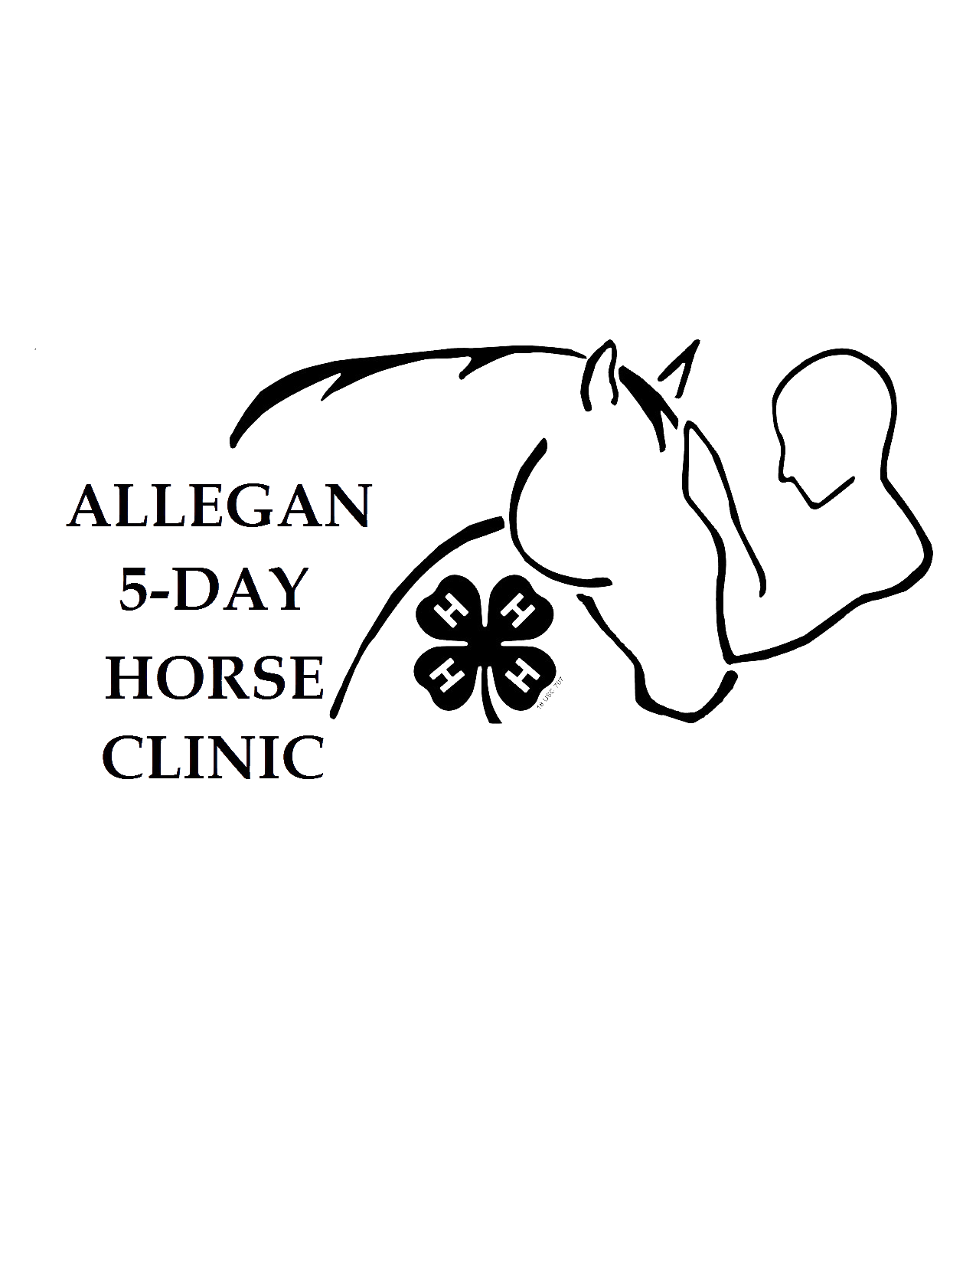
C) West 1 D) Trail 2/3
Upper Parking Lot) Cross Country 4/5

Session 4 2:00-3:30pm
A) West 3 B) Dressage 3/4/5
C) Gym 1 D) Trail 4/5

Session 5 4:00-5:30pm
A) Western 2 B) Western Performance 3/4/5
C) Cloverbuds D) Trail 1

Session 6 6:00-7:30
A) Gymkhana 4/5 B) *************
C) Gymkhana 2/3 D) ************

Allegan 5 Day Clinic Schedule of Events

Friday, June 19th , 2026
- 10am-4pm: Arrival!
- Choose a campsite and report your campsite # at the registration office.
- Settle horse/pony in stall. Make sure stall card is visible.
- Check in with Paul and Health Officer at the office.
- Stall decorating begins.
- 4pm-4:30pm: Mandatory Clinic Orientation at announcers booth.
- 5pm-Vet checks begin
- 6pm-7:30: Session 6
- 8pm-9:30: Session 7

Saturday, June 20 , 2026
- Tack sale begins in posse barn. Bring your items clearly marked with name, phone #, and price to be displayed.
- Finish stall decorations

Sunday, June 21 , 2026
- 10am Judging begins for stall decorations
- 8pm Ice Cream Social “Potluck Style!” Bring a topping to share! Ice Cream and Cones will be provided. You may bring your own bowl! Stall winners announced!

Monday, June 22 , 2026

Tuesday, June 23, 2026
- Voting for Smilely award begins
- Evaluations available online
- 6pm-Timers will be set up for Gymkhana runs for session 6
- 8pm-Clinic Show featuring vaulting teams, ceremony after
- Shaving cream fight after awards ceremony. Bring goggles!!!

Wednesday, June 24, 2026-Clinic ends after Session 5-Good Bye 'till we see you in 2027!
- Get checkout passport from the office
- After your last class get your “class completion” stamp on your passport from your instructor
- Clean horse/pony's stall. Nothing can be left in or on the stall walls
- Check out with a Barn Manager-get your passport stamped!
- Check out with the Health Officer-get your passport stamped
- Checkout with the Clinic Coordinator-get your passport stamped and end of clinic reward.
2026 Allegan County 4-H Five Day Horse Clinic Registration Form
Use only if Online Registration is not possible

Participant's Name: Age as of Jan 1, 2026
Address: City:
County: Zip code: Horse/Pony’s Name:
Parent/Guardian Phone #
4-H Member:(circle one) Yes or No If Yes, 4-H Horse Club: _______

Stalling at clinic or Trailering in Daily

Clinic T-Shirt $5 Size: (circle one)Yth. S Yth M Yth L Adult S M L XL XXL Extra T-Shirts $15 each______________

Horsemaster Level Evaluated by: on (month/year)
Sessions 1-6 (90minutes classes): $65.00 per class or 3 class discount $180.00
Choice 1
Choice 2
Choice 3
1. Sessions 1-6 ($65 each or 3 class discount $180.00 Total $
2. Clinic T-shirt ($5 for Yth. S-XL Adult $8 2XL and 3XL) Hooded long sleeve T-shirt option available Total $
3. Extra T-shirt(s) $15 each up to XL $18 for 2XL and up Total $
4. Camping June 20th-25th Flat fee $200.00 Total $___________
5. Camper drop off Thursday July 20th for $40? Yes No Total $
6.. If registering after July 9th? Late fee $15 Total $
Sub Total $
Incentives -$
subtract
Amount enclosed $
Make checks payable to: Allegan County Five Day Clinic
Mail checks to: Kerisa Desimone 2797 10th ST Shelbyville MI 49344 . Include any earned incentives with your payment or email to allegan5day@gmail.com

Consent Statement: I give my permission for my child to attend the 2026 Allegan County 4-H Five Day Horse Clinic at the Allegan County Fairgrounds. My child and I also agree to abide by all 4-H and clinic rules and regulations.
I give my permission for my child to stay overnight with the following 4-H Leader:

Participant's Signature Date

Parent/Guardian's Signature Date

Phone#_______________________Email:_____________________________________________________________

Please make sure your media release and medical treatment authorization is up to date on 4-H Online – The office will print these forms for you.

MSU is an affirmative-action, equal-opportunity employer. Michigan State University Extension programs and materials are open to all without regard to race, color, national origin, sex, gender, gender identity, religion, age, height, weight, disability, political beliefs, sexual orientation, marital status, family status or veteran status
.2026 5-DAY HORSE CLINIC CAMPING AGREEMENT FORM
(This form to be completed by parents/guardians)

I(WE) AGREE TO THE FOLLOWING TERMS IN ORDER TO CAMP AT THE ALLEGAN COUNTY FAIRGROUNDS DURING 5-DAY HORSE CLINC:
- Overnight camping at the Allegan County Fairgrounds during the 4-H Five-Day Horse Clinic is available for participant families and club leaders on a first come first serve basis. Parents wanting to have their children stay with an unrelated adult at campgrounds must give written permission below.
- The fee for camping will be $40.00 per night per campsite. Fee includes electric and water hookup. Camping fees are due with registration.
- Campers must be brought in AFTER10am FRIDAY MORNING and must be removed from the campgrounds at the end of clinic on Wednesday, June th. Please no horse trailers in camping sites unless camping in said trailer.
- Youth may camp at the fairgrounds only with their parent(s), legal guardian(s) or club leader. That adult assumes full responsibility during overnight stays and other times the youth is not involved in clinic activities. A signed permission form is required if a 4H Chaperone (VSP screened) is responsible for the attending youth. NOTE: If your child is not staying with a parent or legal guardian it is the parents responsibility to make sure their child is staying with a 4H Chaperone (VSP screened) AND one other youth.
- The Allegan County 4-H program, 4-H Horse Leaders Association, 4-H Five Day Horse Clinic and the Allegan County Fair will not be responsible for loss or damage of horses, tack, feed or vehicles.
- No camp fires of any kind are allowed. However, grills may be used for cooking.
- Due to past problems there will be no dogs or bikes allowed at clinic.
- Youth are to stay away from barns from 10:30pm until 6:30am unless authorized by a Barn Manager or there is an emergency. Quiet time begins at 11:00pm Please be considerate of other campers that need to sleep prior to 11:00pm.
- Horses are not allowed in the camping area.
- Anyone not following rules and/or caught in the act of theft, vandalism, possession of drugs or alcohol, shall immediately be told to leave the fairgrounds or if the offense warrants it, the offender may be turned over to the proper authorities. No refund will be given.
- No dogs or bikes.

Name of Participating Youth

My child will be camping with a parent/legal guardian or related adult? YES or NO
OR
My Child will be camping with a 4H Chaperone (VSP screened)? YES or NO

If Yes, Name of 4H leader?

Name of other youth staying with 4H leader?

Parent/legal guardian signature Date

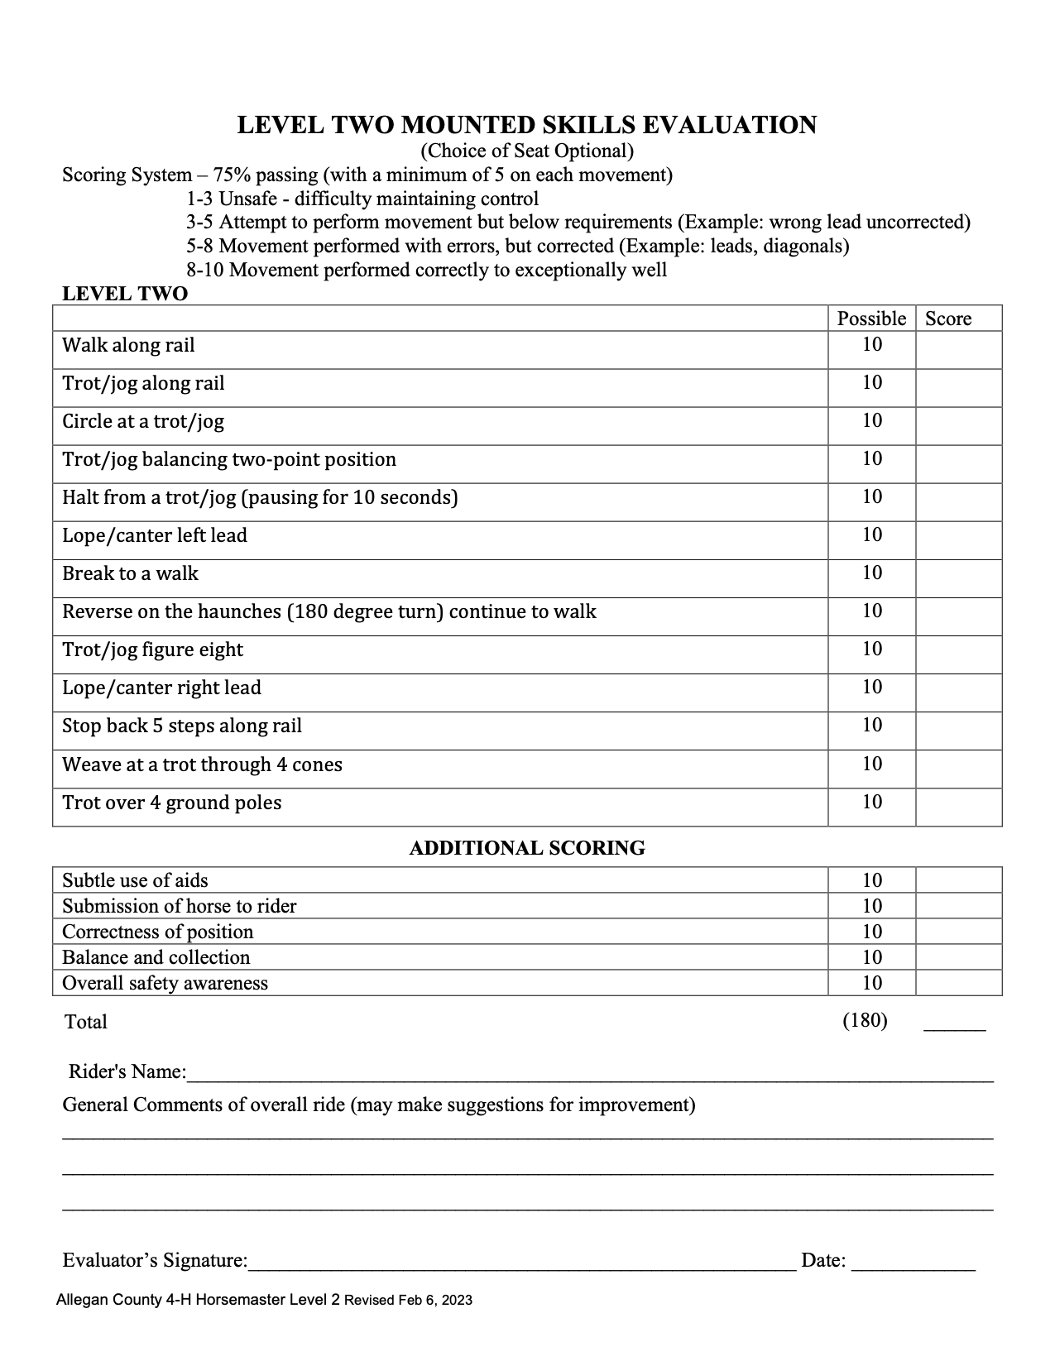
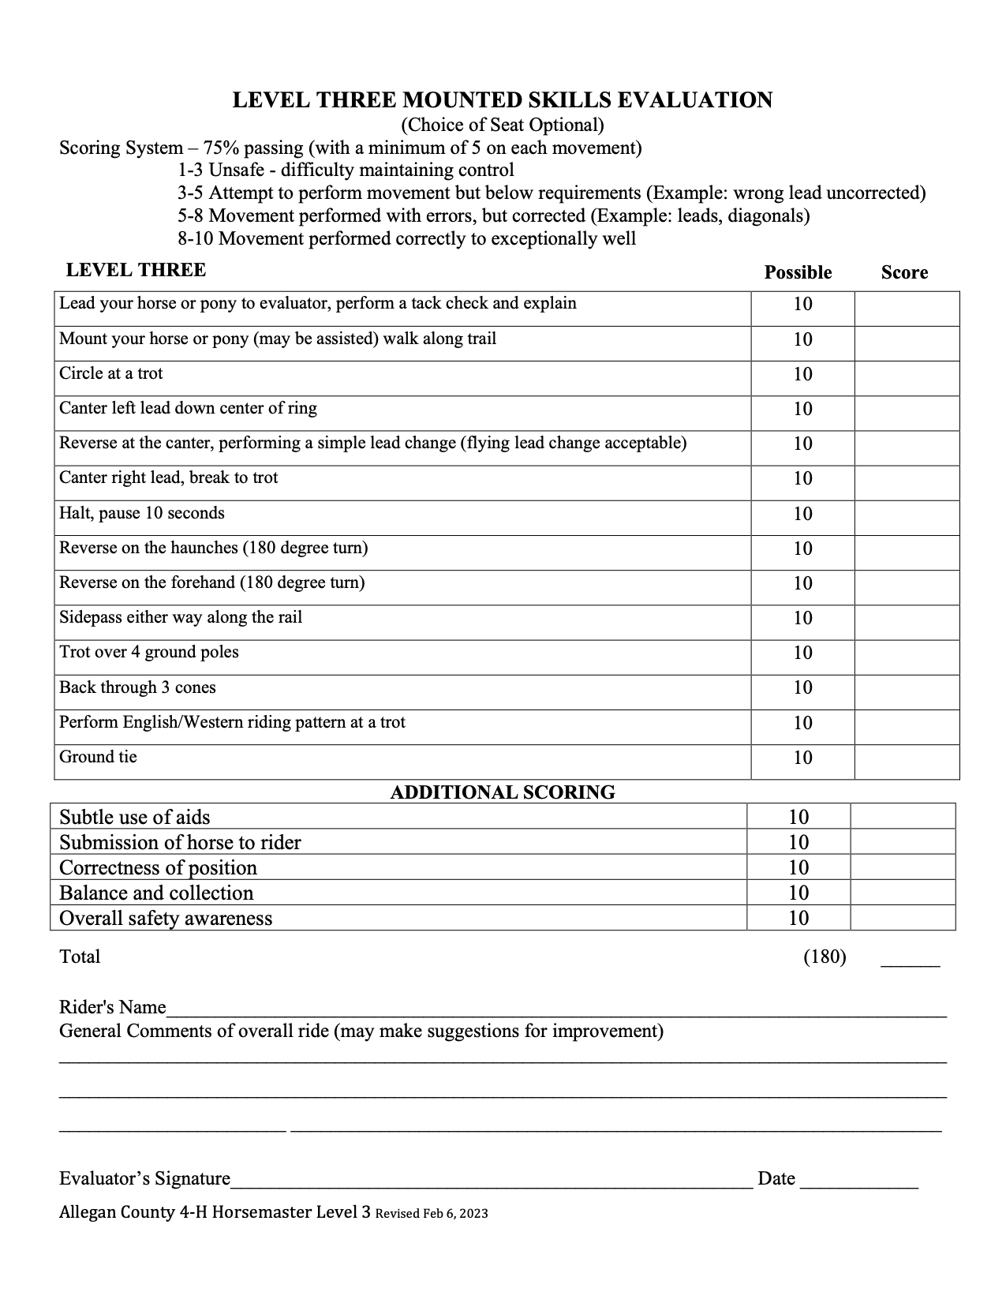
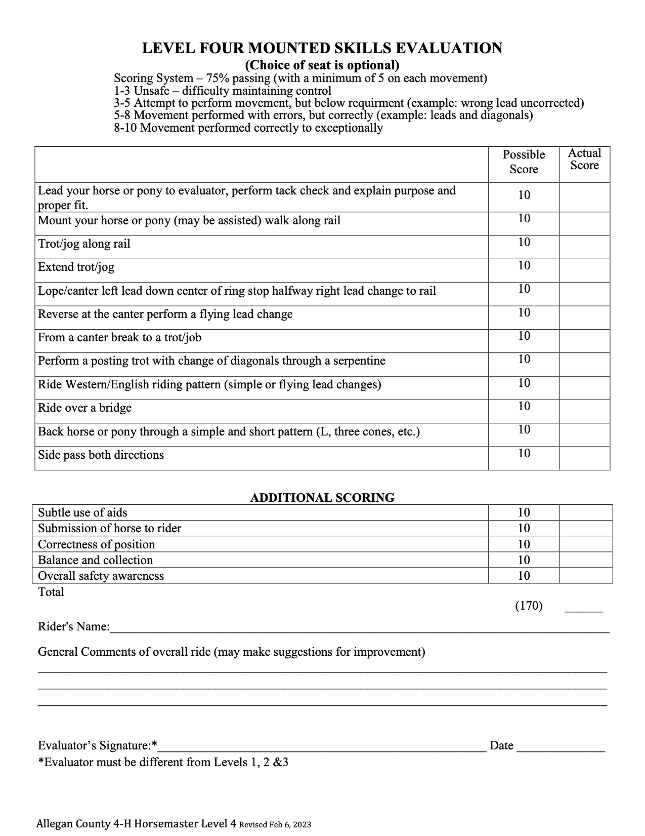

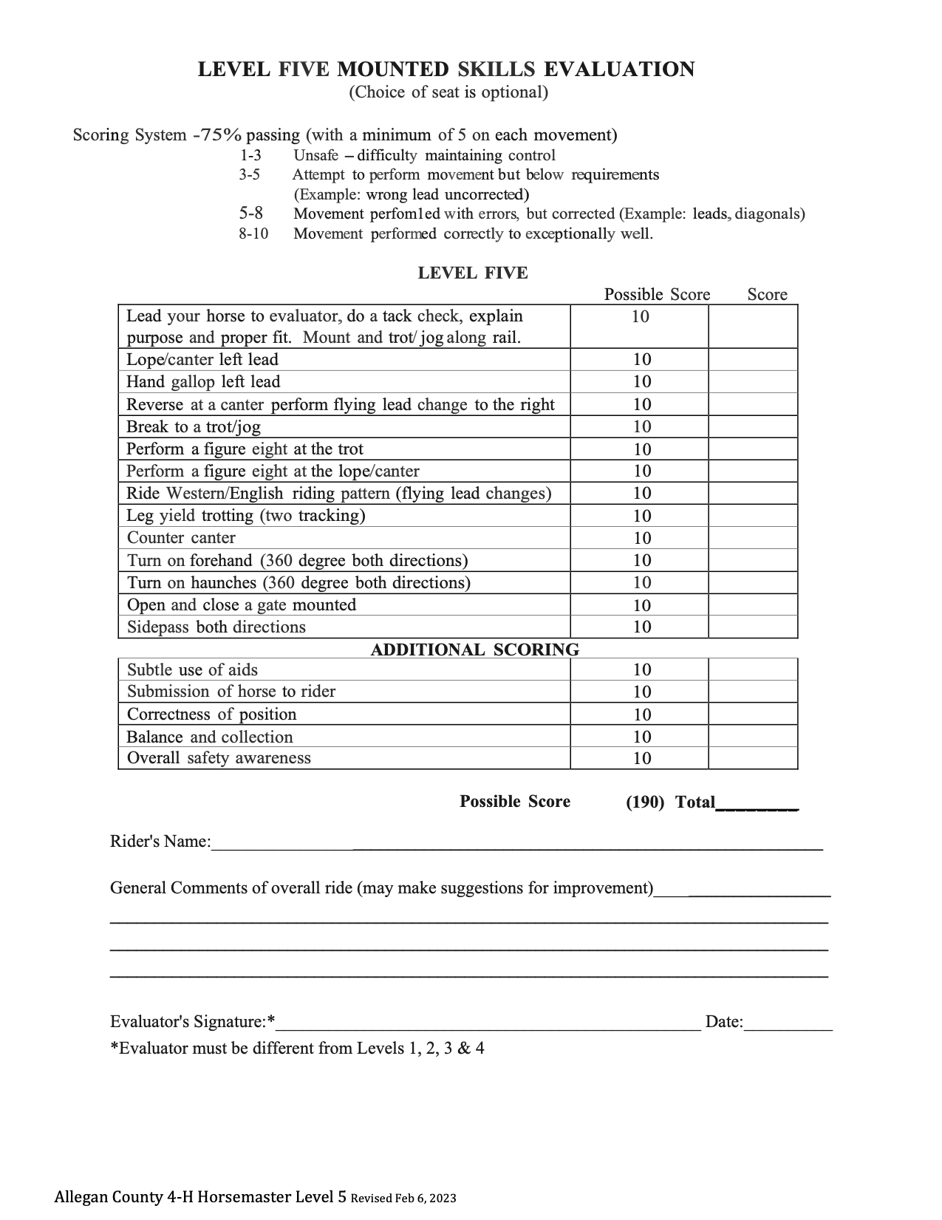
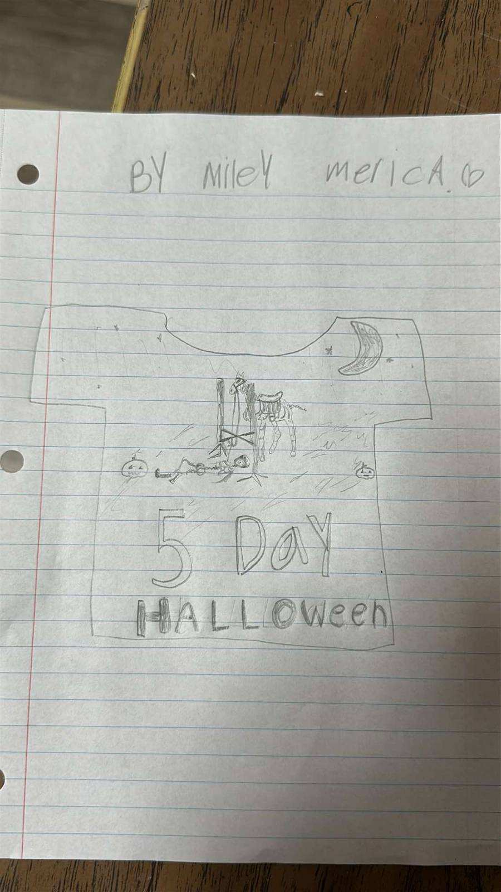

Photo Credit: Miley Merica

See you soon!!!!

June 19th , 2026 To June 24th , 2026

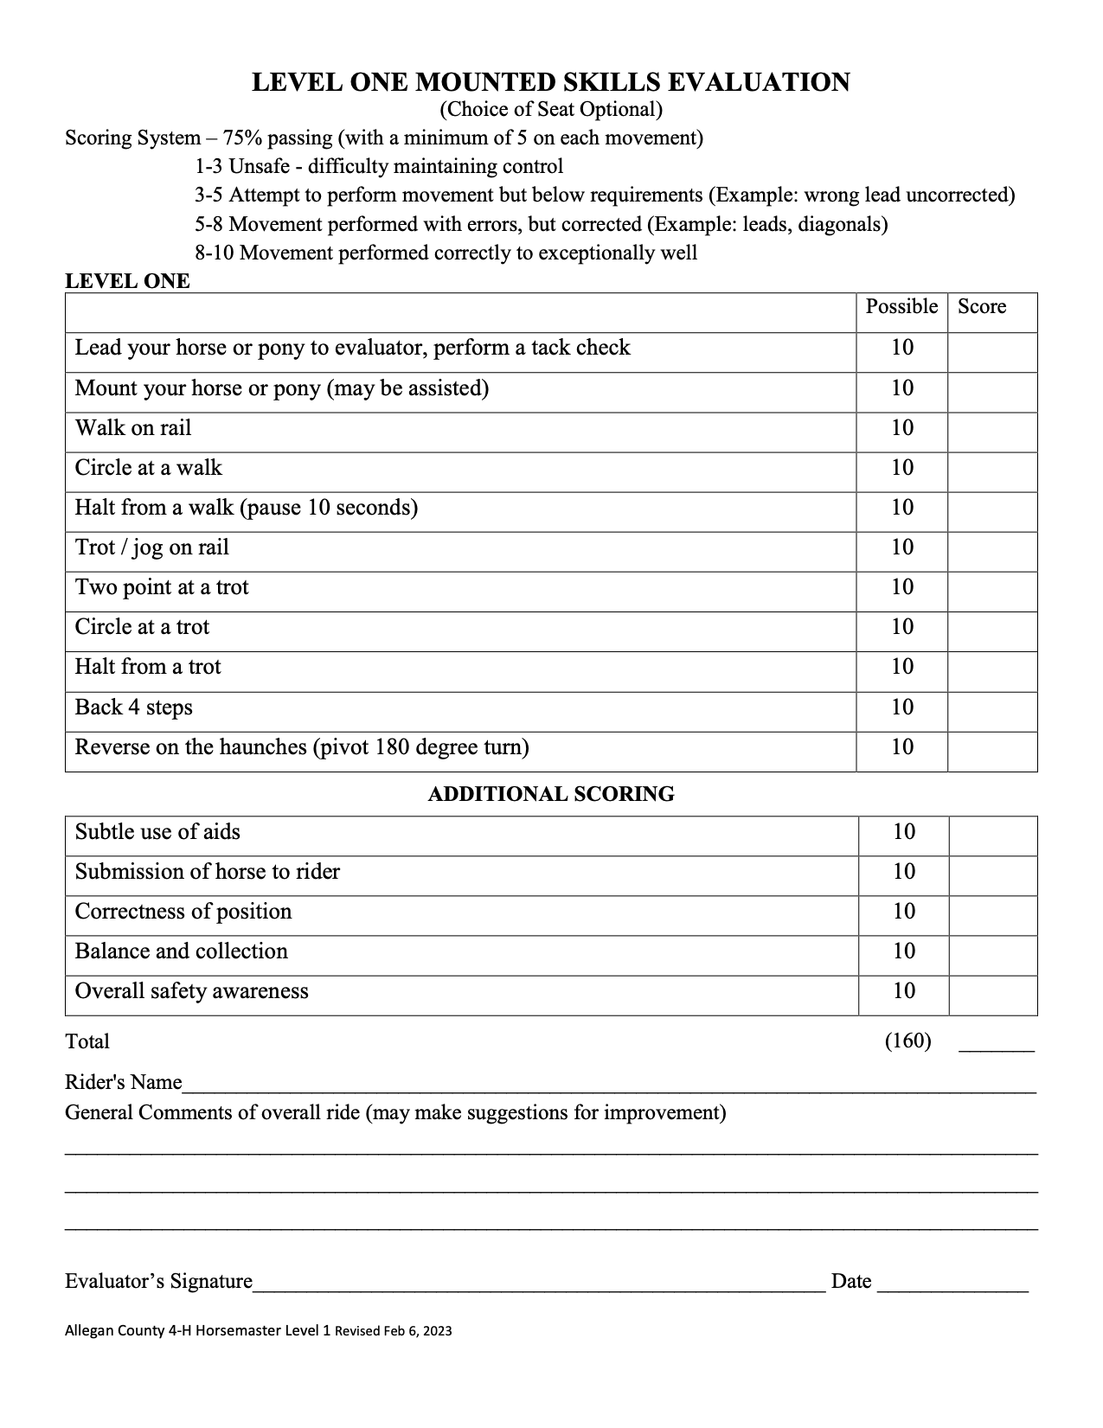
MSU is an affirmative-action, equal-opportunity employer. Michigan State University Extension programs and materials are open to all without regard to race, color, national origin, sex, gender, gender identity, religion, age, height, weight, disability, political beliefs, sexual orientation, marital status, family status or veteran status.

